HIST 497 Epidemics in American History
Summer 2025

Course Schedule and Start and End Dates:
Asynchronous online
June 23-July 25, 2025
Instructor: Prof. Sonic Woytonik (sonic.woytonik@unh.edu)

Course Description
HIST 497 – 4 credits

Course description – In-depth exploration of a particular historical question or topic: for example, the French Revolution, Chaucer's England, or the New Deal. Students should consult with the Department of History for a list of topics and instructors. Course meets the History major requirements for Group I, II, or III, depending on the topic. May be repeated for a maximum of 8 credits.

Topic: Epidemic Diseases in American History
In this course, students will explore the American past through the careful examination of 8 outbreaks and epidemics between the colonial era and the present: smallpox, yellow fever, typhoid fever, influenza, tuberculosis, polio, HIV/AIDS, and COVID-19. Students will use case studies to uncover the impact of these diseases on American medicine, politics, economy, demographics, and the daily lives of affected individuals. Students will gain research skills through extensive use of primary sources including newspapers, diaries, archaeological findings, and oral traditions of illness as well as modern sources like photographs, blogs, news, and digital media, and representations of disease on television and film. We will seek to explore the ways that past Americans reacted differently to outbreaks of disease, as well as the ways that our modern experience mirrors the past.

Rules of Engagement:
Medical history is an interdisciplinary profession, drawing on expertise, experiences, opinions, practices and theories from several other disciplines. Success as a student in the course is dependent on the student’s ability to think critically, listen actively, investigate thoroughly, and to engage in respectful, polite and disciplined discourse. Understanding and tolerating alternate points of view and opinions is required. This means that, in class, we may have disagreements and debates; and through such discourse, our understanding of security requirements and strategies can deepen. It is possible to vehemently disagree and still maintain an academic, professional environment. Through the lens of science and medicine, expect to contend with controversial issues and historical ideas that radically differ from today’s scientific knowledge and worldviews.

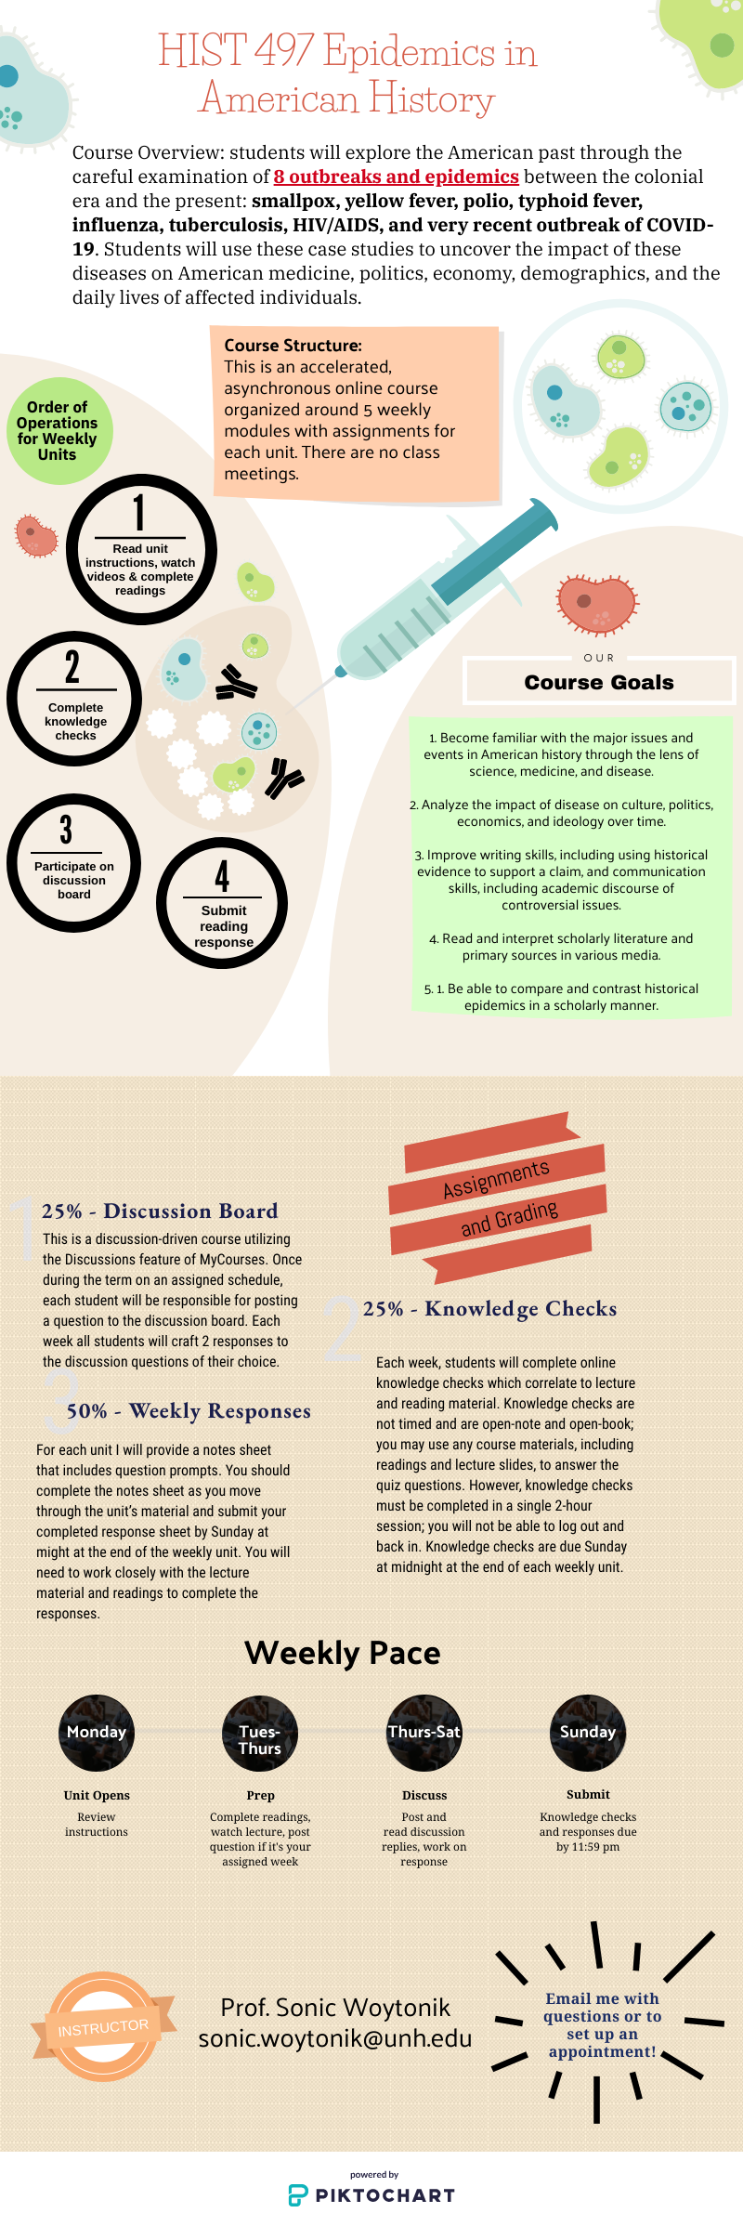

Course Structure

This course is an online accelerated 5-week course in an asynchronous format.

Netiquette Guidelines
Netiquette is the socially and professionally acceptable way to communicate on the Internet. Please abide by these guidelines of "netiquette" when using online communication tools with your classmates and instructor.

In discussion boards and email messages:

- Identify yourself. Begin messages with a greeting and close with your name.
- Avoid sarcasm. It can be misinterpreted and cause hurt feelings.
- Keep the dialog collegial and professional. Some discussion topics may be controversial.
- Do not flame -These are outbursts of extreme emotion or opinion. Think twice before you submit a response.
- Do not use offensive language or profanity.
- Use clear subject lines for your posts.
- Do not use all caps. It is the online equivalent of YELLING!
- Be forgiving. Anyone can make a mistake.
- Cite all sources in discussion posts if you quote or paraphrase. You can also cite classmates’ posts as sources – give credit where credit is due.

The instructor reserves the right to remove posts that do not conform to course standards.

Methods, Grade Components, Academic Integrity and Extra Credit

Final grades are determined according to UNH guidelines: http://www.unh.edu/registrar/grades-transcripts/entering-grades.html using this schema:

Letter | Range
A | 100 % | to | 94 %
A- | < 94 % | to | 90 %
B+ | < 90 % | to | 87 %
B | < 87 % | to | 84 %
B- | < 84 % | to | 80 %
C+ | < 80 % | to | 77 %
C | < 77 % | to | 74 %
C- | < 74 % | to | 70 %
D+ | < 70 % | to | 67 %
D | < 67 % | to | 64 %

D- | < 64 % | to | 60 %
F | < 60 % | to | 0 %

UNH considers the minimum passing grade as D-. A C- is the minimum grade to count this course in the HLS major.

Late Submissions
The structure of this course is planned so that each week has a rhythm to the assignments due. Late submissions lessen the effectiveness of the collaborative activities and subsequent assignments; you and your peers cannot comment and build on each other’s work if that work is not shared in a timely manner. Discussion threads will close at 11:59 pm on Sundays and late comments cannot be added.

Unit quizzes can be taken up to 24 hours late, with a 5 point penalty. After 24 hours, access to the quiz will close and correct answers will be available to view.

Notes sheets will be deducted a third of a letter grade per 24 hours late.

If you are experience an illness or life event that will result in work being late, I recommend you contact me as soon as an issue arises so we can make a plan.

Please note that no work can be accepted after the end of the term on July 25.

Instructor Availability and Communication
Meetings by Appointment – By Phone, in Person or via Private Teams Session
I am happy to talk with you one-on-one, for any reason. You may request to meet with me by phone, in person or via a private Teams session (a one-on-one video- conferenced discussion which I will set up in response to your request). Email me directly to schedule an appointment.

My Communication With You
It is my policy to facilitate student collaboration in classroom activities and online discussion boards without too much “interference” from the instructor. That said, I may occasionally inject comments into activities to prompt deeper thinking or to redirect conversations that may have strayed from the learning objectives. I will not send supplemental email reminders of due dates for class activities or assignments – you can see these dates in the syllabus, on the course home page, and on your Canvas calendar.

I may also moderate discussion board posts only to the extent that I find any comment or material inappropriate or disrespectful.

How to Reach Me
Questions related to assignments or learning should first be asked, if possible, in the discussion board called “Course Questions” (this way all students can benefit from the questions and answers). If you have a question that only pertains to your individual situation, please reach out to me via email: sonic.woytonik@unh.edu.

Student Accessibility Services
The University is committed to providing students with documented disabilities equal access to all university programs and facilities. If you think you have a disability requiring accommodations, you must register with the Accessibility Services Office by emailing Student Accessibility Services: https://www.unh.edu/diversity- inclusion/student-accessibility

If you register with SAS and obtain an accommodation, the instructor will be notified directly by SAS. If you need to discuss any SAS-related matter with the instructor, please do so privately (i.e., not on a class discussion board).

Academic Integrity

Students are required to abide by the UNH Academic Honesty policy located in the Student Rights, Rules, and Responsibilities Handbook: http://www.unh.edu/vpsas/handbook/academic- honesty.
You are expected to prepare and present your own work to satisfy academic requirements. UNH considers academic dishonesty a very serious offense. The Academic Integrity violations process is followed in all cases of suspected academic dishonesty. Sanctions may include failure of a test or assignment, failure of a course, suspension, or dismissal from the University. Academic Integrity violations include the following items:
- Cheating: Students may not use unauthorized assistance in preparing assignments or completing exams. This includes any oral or written presentations within the academic setting. In our course, use of chatGPT and other AI tools is not permitted.
- Fraud: Students may not gain unfair advantage through deceit or trickery, including falsification of records. In addition, unless a student has been granted prior permission from each professor, double/multiple submission (submitting identical or substantially similar written assignments to fulfill a requirement in more than one course, regardless of term) constitutes one form of academic fraud.
- Plagiarism: Plagiarism is recognized by the University as an act of academic dishonesty. It is defined as taking the ideas, writings, and/or words of another and representing them as one’s own. Two common forms of plagiarism involve the use of written or oral work of another person without giving proper acknowledgment and the use of the work of another person as one’s own. Additionally, buying, selling, trading papers, projects, computer programs or other academic assignments; or fraud, including the intent to commit one of these acts, constitutes plagiarism. If you have questions about proper citation, please contact me or your librarians.

- Additional resources are found at: http://libraryguides.unh.edu/unhmcitingsources

An academic integrity violation will go before the Honor Board when it is the second offense for undergraduate students or in the event that a student’s disciplinary record in conjunction with the Academic Integrity charge meets the threshold of possible suspension. In instances of broad cheating or in combination with other violations (such as computer security policies, false information, etc.), a case could be elevated to the Honor Board for adjudication and possible suspension or dismissal.

